**CSE327.1 Business Case**

ForRent.com

Submitted by

Kazi Muntashir Muzib – 141 0464 042

Md. Samiul Kabir – 132 0751 042

Mahmudur Rashid – 151 1966 042

Moh. Anwar-ul-Azim Bhuiyan – 141 1181 042

Pias Paul – 141 0542 042

Md. Fazle Rashed Khan – 132 0237 642

Submitted to

Dr. Nabeel Mohammed – NbM

A common problem that city-dwellers face is finding an apartment to live in and finding a suitable one is no easy task. One has to go to different areas to check whether any of the hundreds of different buildings contain an apartment for rent, and then again they rarely meet all their requirements. As a result most of the time people end up settling with the ones they find because of all the hassle it takes to find the right one. To overcome this problem, we have taken up the project of building a website which connects apartment owners with people who are interested in renting apartments. The website aims to make house renting procedures hassle free for both parties and it delivers exactly what they are looking for without them going through all the hassle of advertisements and physically searching.

ForRent.com allows users to put their flats for rent and as well as to search for the perfect place to live. It is the only solution of its kind that allows users to look for apartments as well as rooms that bachelors can share. Here the User or owner of apartments as well as the manager of a bachelor apartment can give their apartment or room details, so that people who are in search of a place to live can check if that apartment or room is suitable for them. The website is open for all to register free of cost and registered users can edit or even delete their apartment information whenever they want by logging into their accounts. ForRent.com makes conventional house renting procedures simple and seamless.

Users looking for a place can filter their search results by location, budget, number of bedrooms, total size of the apartment, amount of rent etc. Users can also compare multiple apartments to find the one best suited for them. The details section of each listing contains pictures of the apartment along with all the necessary information that the user may require like the lift/ generator facilities, room details, rent breakdown and any terms and conditions. They can also get the apartment address and the owner’s contact information and preferred contact hours so that they can make arrangements to check the apartments physically.

The front-end of ForRent.com will be made using jQuery and a bootstrap template of a typical e-commerce site and a MySQL database will be made in phpmyadmin. The front-end and the back-end will then be connected using the CodeIgniter framework, which utilizes the MVC pattern. MVC stands for Model-View-Controller. It helps to connect the front-end and back-end of a website or web application by organising the codes into three interconnected parts. The database is managed in the Model section, the front-end code is managed by the View section and finally the php code that connects the database to the front-end is managed by the Controller section. The resulting application will then hosted be on a server. Initial testing will be done by hosting on a XAMPP Local Server.

Feature list:

* **Add Apartment Details:**

The owner of the Apartment or the Manager of a Bachelor Apartment can put their apartment/room details in the website. First they will need to sign up with some basic information and then log in. After logging in they can add their apartments by filling the add apartment form in the website.

* **Availability and Shareability:**

Users can easily check if the apartments they are looking for are available, or in case of rooms, whether the manager allows multiple people to share a single room.

* **Filtered Search:**

The user can filter the search results by the place of the apartment, the size of the apartment, number of bedrooms, their budget for rent etc. It will help the user to easily find out the apartments that they are looking for and the ones that they can afford as well.

* **Insightful User Dashboard:**

The user dashboard of ForRent.com shows basic contact information of the user as well as their convenient times when interested customers can call them. The user dashboard also features all the listings of the user.

* **Apartment/Room Facilities Overview:**

Users interested in an apartment/room can see whether their chosen entity has a list of facilities like generator, lift, Wi-Fi, etc. at a glance.

ER Diagrams:

Simplified version

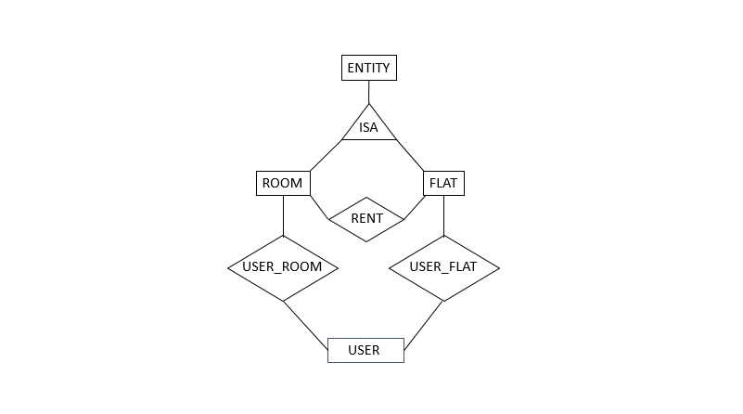

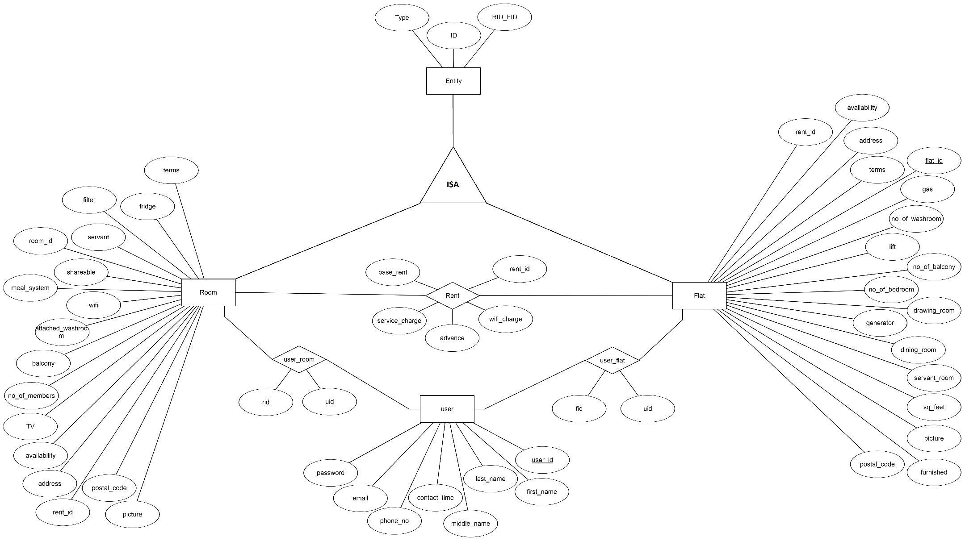

References:

1. Bootstrap reference guide - <https://www.w3schools.com/bootstrap/>
2. PHP reference guide - <https://www.w3schools.com/php/default.asp>
3. jQuery UI Elements - <https://jqueryui.com/>
4. MVC Wikipedia - <https://en.wikipedia.org/wiki/Model%E2%80%93view%E2%80%93controller>
5. CodeIgniter Database Reference - <https://www.codeigniter.com/user_guide/database/index.html>
6. CodeIgniter Sample Project YouTube Tutorial - <https://www.youtube.com/watch?v=I752ofYu7ag>